Website Upgrade
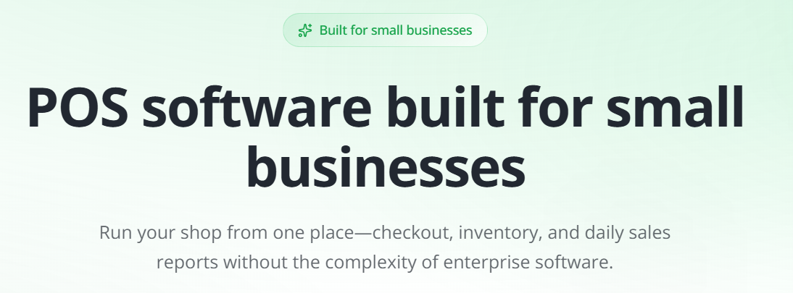

- HERO

Headline: Run Your Business. Know Your Numbers.

Supporting message
Excelite helps you sell, manage your shop, track your stock and see how your business is doing—all in one simple system.

- Replace buttons


Primary CTA: Chat on WhatsApp.

Secondary CTA: BOOK A DEMO

Small supporting line under CTA buttons:
Easy to understand. Simple to use. Built for your business

- Positioning Statement

Replace this

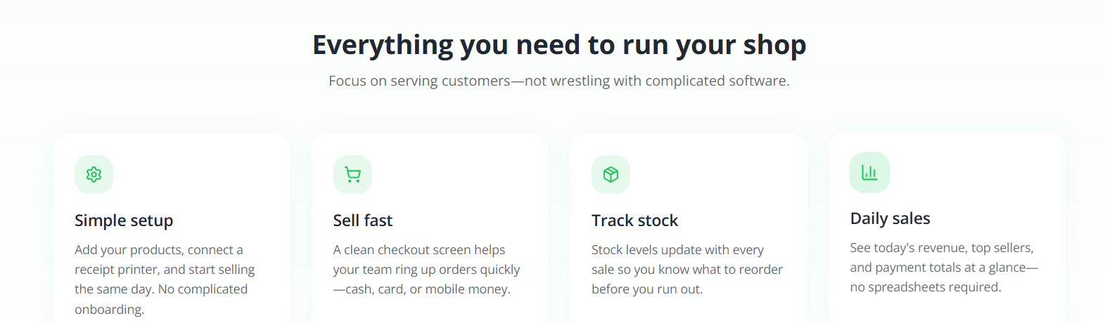

Everything You Need. Nothing You Don't.
Running a business is already hard. Your software shouldn't make it harder.
Excelite gives you the tools you need to run your day-to-day business without complicated features you may never use.
Then 4 simple cards:
Sell Easily | Take orders and payments quickly, even when the internet goes off.
Know Your Sales | See how much you've sold and how your business is doing.
Keep Track of Stock | Know what you have, what's selling and what needs to be replaced.
Bank-Ready Sales Records | Generate trusted sales reports that make it easy for banks to approve loans for your business.

- Change header of “How it works” to “Easy to Setup and Use”
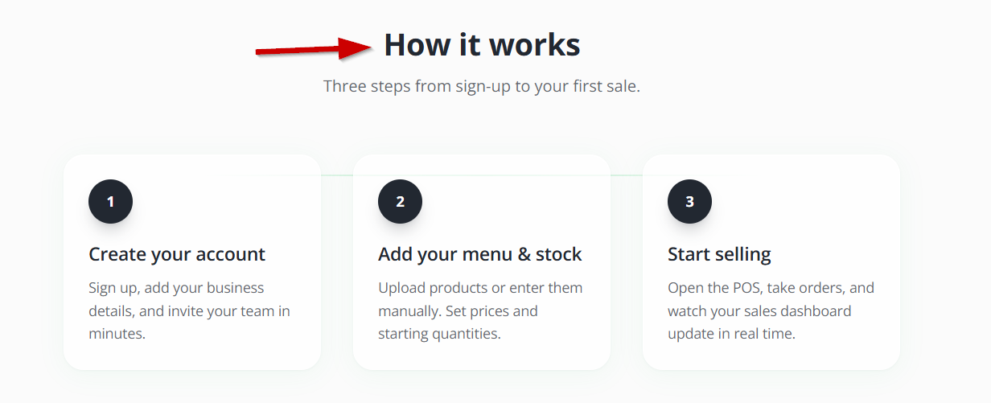

For step 1, change it from “Create your account” to
“Sign Up”
Set up your account, enter your business details, add your staff in minutes

- Replace the “Common questions” section with below

Simple Answers. Clear Choices.

1. What is Excelite?
Excelite is a simple business management and POS system built for small and growing food and retail businesses. It helps you take sales, manage orders, keep track of stock and see how your business is doing—all in one place.

2. Why should I choose Excelite instead of another POS?
Excelite is built with the needs of Ghanaian businesses in mind. While many POS systems are designed for a broad international market, Excelite focuses on the way businesses here actually operate.
You get the essential tools you need to run your business without paying for complicated features you may never use. Excelite is simple to learn, easy to use and affordable, while giving you the information you need to stay in control.

3. Can I still sell if my internet goes off?
Yes.
Excelite's offline mode allows you to continue taking sales even when your internet connection is down. Once your connection comes back, your sales sync automatically.
Your business doesn't have to stop because the internet does.

4. Will my staff find Excelite difficult to use?
No. Excelite is designed to be easy to learn and easy to use. No IT background or technical skill required.
The system keeps the features and processes straightforward, so staff can quickly understand how to take orders, complete sales and carry out their daily tasks to help your business grow.

5. Can Excelite help me keep track of my orders and payments?
Yes.
Excelite gives you a clear view of your orders, including dine-in, takeout and delivery orders. You can also see how customers paid (Cash, MoMo, Card), helping you keep better track of your sales and payments. This gives you a clearer picture of what is happening across your business throughout the day.

6. Can Excelite help me keep track of my stock?
Yes.
Excelite helps you keep track of your stock, see what is selling and get alerts when important items are running low. This helps you avoid unnecessary shortages and reduce waste.

7. Can Excelite help me prove how my business is performing?
Yes.
The reports in Excelite give you a clear record of your business performance, including sales and other important business information. These reports can help you make better decisions about your business and provide useful records when you need to demonstrate your business activity - for example, when applying for bank loans or government credit.

8. Is Excelite only for restaurants?
No. Excelite is built for single-branch food and retail businesses.
It can be useful for Fast Food Outlets, Local Eateries, Cafés, Provisions & Grocery Stores, Cold store, Hardware Stores, Boutiques & Beauty Shops, Electronics Stores, Chemist Shops, Household Item Stores and other small businesses that need a simple way to manage sales, orders and stock. Contact us if you have multiple branches and need a reliable alternative.

9. Is Excelite difficult to set up and learn?
Not at all. Excelite is designed to get your business up and running quickly.
The setup is straightforward, and the system focuses on simple, practical features that your business needs every day. All you need is an internet capable tablet or POS device. Your team can learn the basics quickly, and reliable customer support is available whenever you need help.

10. How do I get started with Excelite?
Getting started is simple.
You can Book a demo to see how Excelite works and discuss what your business needs, or “Get Started” to start your account creation.

Ready to run your business with less stress? Contact Us today via Whatsapp

RULES FOR BUTTONS
- Rule: When “Chat on Whatsapp” is selected, it should take the user to whatsapp to start an automated response messaging

- BOOK A DEMO
Intro text:
See how Excelite can work for your business. Choose a convenient time and tell us a little about your business so we can make the demo relevant to you.
Field | Type | Required
Your Name | Short text | Yes
Business Name | Short text | Yes
Phone / WhatsApp Number | Phone | Yes
Business Type | Short Text | Yes
Preferred Demo Date | Date picker | Yes
How would you prefer we contact you? | WhatsApp / Phone Call | Yes
What would you like to see in the demo? | Multi-select | Optional

“What would you like to see in the demo?”
Checkboxes:
- POS & Taking Orders
- Sales & Business Reports
- Stock Management
- Orders & Payments
- How Excelite Works Overall
- Not Sure — Show Me Around

Button – “Book My Demo”

Confirmation Message
After submission:
Your demo request has been received.
A member of the Excelite team will contact you to confirm the date and time.

Other Changes
- Update the “title or menu” bar
  - Remove “sign In” button at top of page
  - Benefit: Remove
  - How it works: Change to “Learn More” - it should take you to “Everything You Need. Nothing You Don't.” section
  - FAQ - let it go “Simple Answers. Clear Choices” section

- Revise text
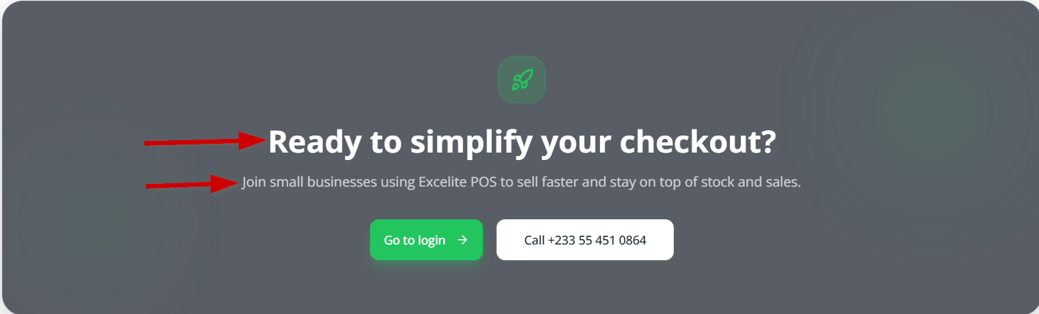
Replacement text below:
Trusted by 800+ Businesses. Grow with Excelite
Excelite helps you make more from every sale, reduce waste and protect your profit.

- Change the “Go to login” button to “Get Started”
- Relate “Call +23355” button with “Chat on Whatsapp”

- Replace image
Remove this
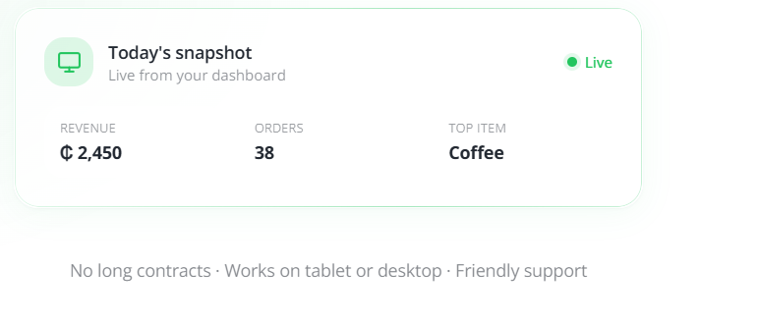

Replace with this
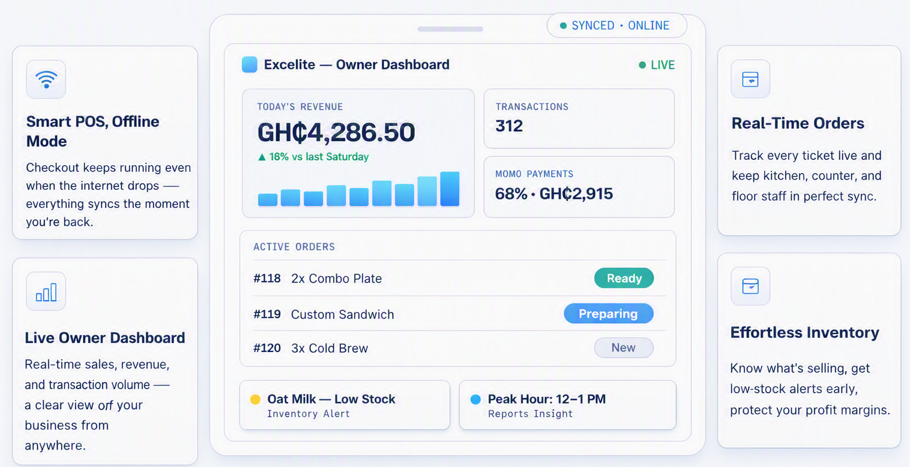

- Update the following footers
  - FAQ - let it go “Simple Answers. Clear Choices” section
  - Login – Remove this
  - Contact – Go to the “Chat on Whatsapp”

